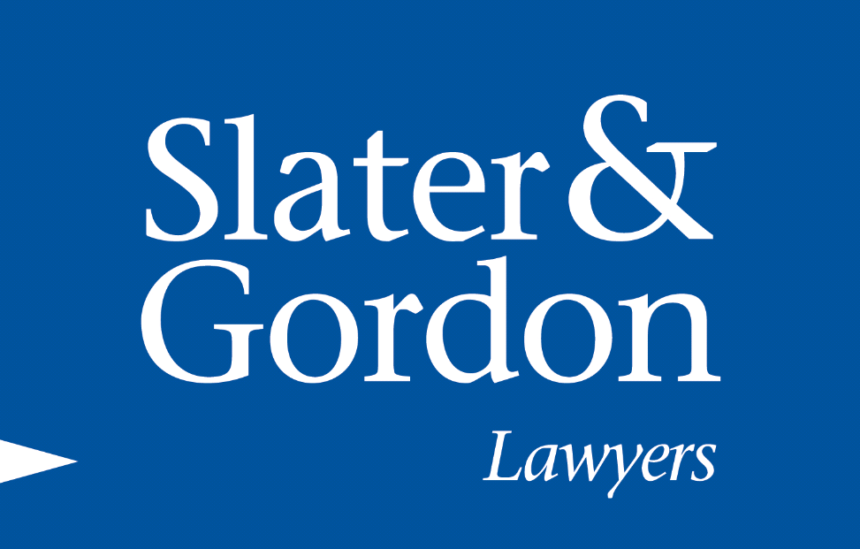
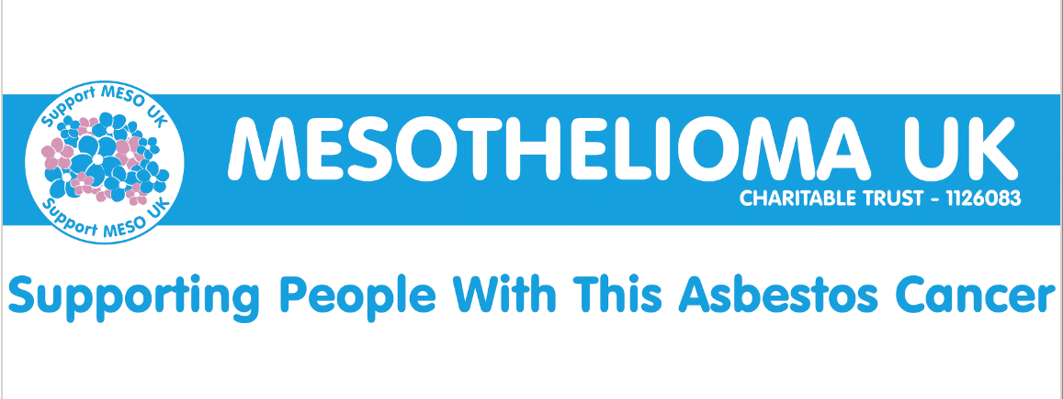
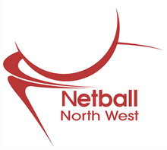

Summer Social Festival 2014
Team registration form
Saturday 9th August 2014, 9:30am registration, 10am prompt start
Wright Robinson College, Abbey Hey Lane, Gorton, Manchester M18 8RL
Outdoor courts

Please complete ALL sections of both forms
Form 1
Team/ club name
County

Contact number
Contact address

Contact email address

As this is a charity tournament we would be grateful if you could bring a prize for the raffle | Please tick the box to confirm you will bring a prize for the raffle
Please state:
- current leagues and divisions that you play in
- How long have you played together?
- Have you played competitively together before (I,e, tournaments)
Can you supply an umpire? (C award minimum required)  If ‘Yes’ please supply umpires name | YES/NO  Umpires name:
If ‘no’, please bring £20 cash & we will do our best to supply an umpire | Please tick the box to confirm you would like us to supply an umpire

All proceeds will be donated to Cancer Research and Mesothelioma UK

Form 2
Squad list (maximum of ten)
No. | Name | Age  (Please Tick box) |  | Medical Information | Emergency Contact Name | Emergency Contact Number | Relationship
 |  | 16 - 19 | 19 +
1
2
3
4
5
6
7
8
9
10

Please return to Lucy O’Gorman (along with the cheque for £40 made payable to North West Netball) by 28th July 2014 to:
England Netball, National Cycle Centre, Stuart Street, Manchester, M11 4DQ
Please note late entries will not be accepted

For any enquiries please email lucy.o’gorman@englandnetball.co.uk

