NW Netball Regional Management Board | 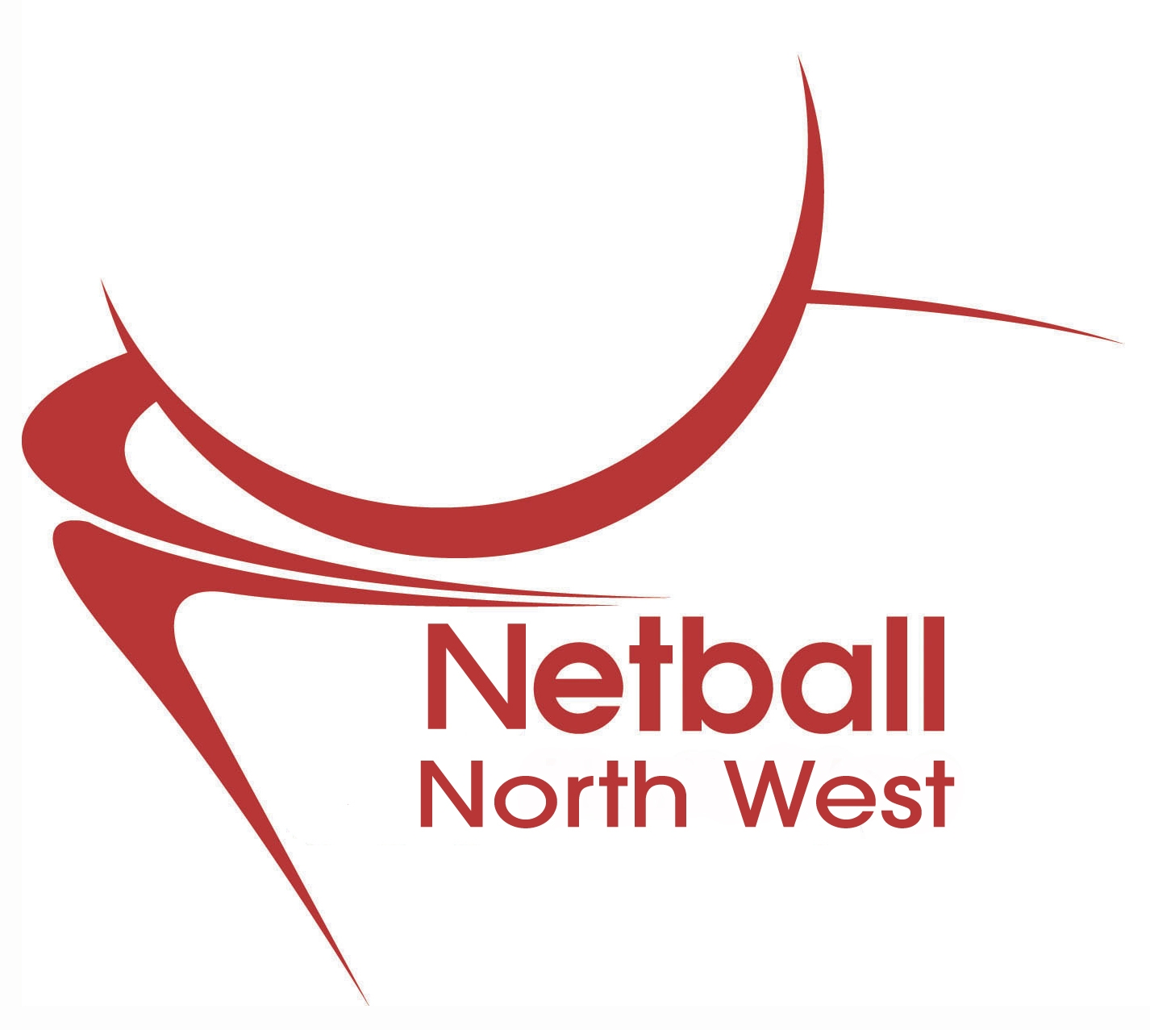
REGIONAL SELECTOR | Application Form

PART A – PERSONAL DETAILS

Surname ……………………………………………..... Foremanes …………………………………………….

Home Address …………………………………………………………………………………………………………………….

Postcode ………………………………………………. Contact email …………………………………………

Mobile phone number ………………………………. Home phone number ………………………………..

PART B- RELEVANT QUALIFICATIONS/AWARDS

Date Qualified Qualification Obtained Awarding body

PART C – CONTINUED PROFESSIONAL DEVELOPMENT – List details of any relevant CPD
Courses/workshops that you have attended in the last 3 years
Courses / Workshops

