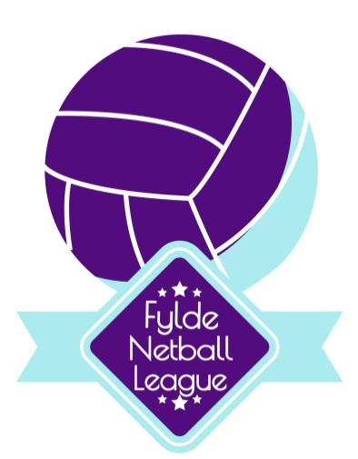

Ladies & Mixed Charity Tournament
Sunday 19th August 2018 & Sunday 30th September 2018

Stanley Park, Blackpool
Registration 09:30am
10:00am Start

In aid of:
LHON Society
Parkinson’s Disease
Stroke Association

Shooting Competition, Raffle,
Great Prizes including World Cup Netball Tickets

£70 per entry -includes 2 umpires per game. £120 for entry to both Ladies & Mixed also £120 for entry to both Tournament dates.

A player can play in both Ladies and Mixed Tournament on the day.

Closing date for August Tournament Monday 5th August 2018.
Closing date for September Tournament Monday 17th September 2018.

Application Forms and details of this event can be found on the Fylde Netball League website: http://www.fyldenetball.co.uk/
& Fylde Netball League Facebook Page

