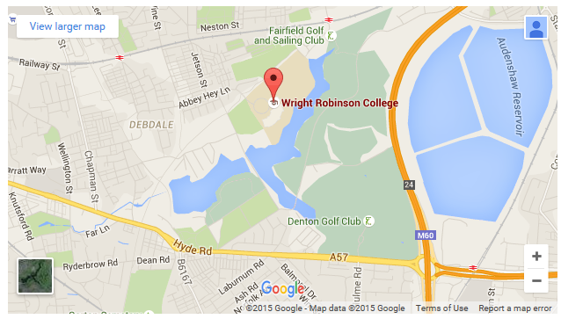
From M60 Leave the M60 at junction 24 (Denton Roundabout) and turn onto the A57 (Manchester Road).
Continue along the A57 (Hyde Road) under the railway bridge past McDonalds.
Take 2nd right after the railway bridge onto Chapman Street.
Continue through 1st set of traffic lights and turn right onto Highmead Street.
Continue along onto Abbey Hey Lane.
Turn right after the Hamlet Public House onto Falmer Close.
Arrive at M18 8RL.

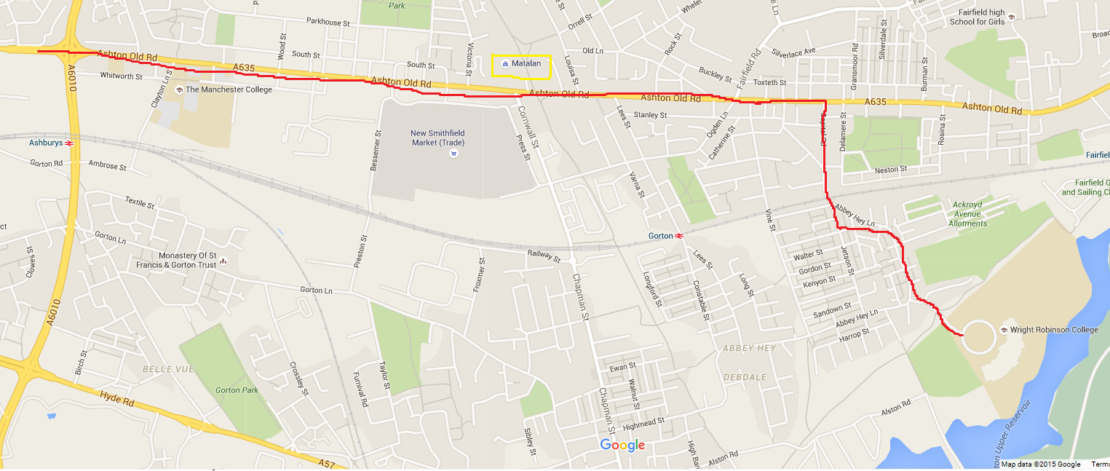

From the city, via the Manchurian way, bear right at the end of the road for A635 Ashton Old Road (turning right at Curry’s) follow this road for 2-3 miles until you pass mcDonalds and Morrisons on left. After the next set of lights, approx. 200 yards, there is a sign on the left next to a church, showing the right turn to the school. Take this right turn, at mini roundabout straight on over littlt bridge, then turn immediately left (at cornershop). Following this round for approx. 200 yards and take sign posted left turn to school. Coach parking is available on overflow car park.

