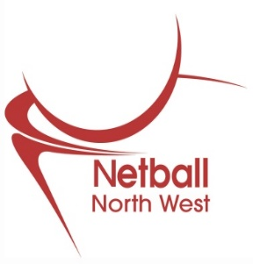

Dear Netball North-West Member

NOTICE OF ANNUAL GENERAL MEETING TO BE HELD
Virtually on Wednesday 16th September 2020 at 7:30pm

Please find enclosed notification of the North West Regional Netball Management Board Annual General Meeting to be held virtually at 7:30pm on Wednesday 16th September 2020

Enclosed with this information you will find:

- Notification of Annual General meeting and Voting Arrangements

- Annual General Meeting Agenda

- Notification of NW Board Elected Member Positions

- Board Members Nomination Form 2020/2021

- Board Nomination: Supporting Evidence Form

- Board Member Roles and Responsibilities

- Minutes from NW AGM 2019

(1)

NOTICE OF ANNUAL GENERAL MEETING TO BE HELD
Virtually on Wednesday 16th September 2020 at 7:30pm

Notice is given to the following Members of the North West Regional Netball Association, who may appoint a representative to attend, speak and vote on their behalf:

- A club with at least seven Registered Participants which is either a Netball Club; the Netball section of a Youth or Community Club; University or College; an U18 Young Person's Group, and which affiliates to a County Association in the North West Region.

- A County Association of the North West Region, which is an association of Clubs affiliated to the County and The North West Region.

- Schools or full time educational establishments for pupils under 19 years of age who pay the higher affiliation fee and affiliate to The County & North West Region. Their main building must be located in the North West Region.

Notice is also given to the following that will be entitled to attend and speak, but not vote:

- Registered participants
A registered participant is a person who plays, coaches, umpires, or organises the game of Netball, or who is in any way connected with the game of Netball. Registration must be through a Club/ Individual and a County Association. A Registered Participant is eligible to serve as a Board Member.

- Honorary life members of the North West
Honorary Life Membership of the North West of the Association may be conferred by the Regional Board upon any person who has rendered a special service to the Association with such rights and privileges as the Regional Board may from time to time determine.

- Associate members
The following shall be eligible for Associate membership of the Association subject to the approval of the Regional Board:
“Any company, association or sports club in the North West Region with an interest in Netball.”

- President and vice-president
The President and Vice-President may be appointed by the Board from time to time. A person so appointed shall hold office for a term of one year, after which such persons shall retire but shall be eligible for re-appointment. The President and Vice-President shall be entitled to receive notice of and attend all general meetings. The president and Vice-President shall otherwise have such rights and privileges, as the directors shall from time to time determine.

Voting at the Annual General Meeting

Each Club may appoint a representative who is a Registered Participant member of that club to speak and vote on its behalf.

Each County association may be represented by the chairman or accredited deputy to speak and vote on its behalf.

Each school may appoint a representative who must be in current employment at the schools represented to speak and vote on its behalf.

In the event of an equality of votes the Chairman of the Meeting shall have a casting vote.

Quorum
No business shall be transacted at a General Meeting unless a quorum is present (10 Voting Members).

Voting
Voting will normally be a show of hands. In calculating a majority only votes cast will be included in the calculations i.e. abstentions will not be included. It is not necessary for 10 votes to be cast for a quorum to be reached, only that 10 votes are available to be cast by representatives present. This can also be achieved through eligible votes being submitted online by relevant voting member by 5pm on Tuesday 8th September 2020.

--------------------------------------------------------------------------------------------------------------

Ordinary Resolution – There is a proposed change to the constitution.
(2)

Northwest Regional Netball Management Board

NOTICE OF ANNUAL GENERAL MEETING TO BE HELD
Virtually on Wednesday 16th September 2020 at 7:30pm

Agenda

7:30pm Annual General Meeting

- Apologies for Absence

- Minutes of previous Annual General Meeting

- Presentation of Board Report and Accounts

- Appointment of Auditors

- Election of Regional Management Board Members

(3)

Northwest Regional Netball Management Board

NOTICE OF ANNUAL GENERAL MEETING TO BE HELD
Virtually on Wednesday 16th September 2020 at 7:30pm

Current NW Regional Management Board applications for 2019/20 include:

Volunteer Chair

Elected Members (voting members)

Chair: Maria Long
Vice Chair Phil Owen
Finance Chair Sarah Sutton
Coaching Chair Vacant
Officiating Chair Ruth Ward
Performance Chair: Sam Longley
Competition Chair: Estelle Graham
Communications and Marketing Chair: Amy Buckle
Volunteer Chair Vacant

Election of North West Regional Management Board

In line with the Constitution of the Northwest Regional Netball Management Board all Elected Member positions are subject to elections at the Annual General Meeting on Wednesday 16th September 2020.

Nominations for these positions may be proposed by a Member entitled to vote at General Meetings and seconded by any Member entitled to vote at such meetings.

Written notice of such nominations for the vacant roles containing the name of the proposer and seconder and the name and address and written consent of the nominee, must reach the NW Regional Office no later than 5pm on Tuesday 8th September 2020. Nomination forms can be found enclosed in this pack. Or are available for download at www.netballnorthwest.org.uk

In the event of their being more than one candidate for any office, the election shall be decided by a ballot of all members at the Annual General Meeting.

Notification of who has been nominated for the additional Elected Member positions shall be posted on the North West Netball website at www.netballnorthwest.org.uk from Friday 11th September 2020.

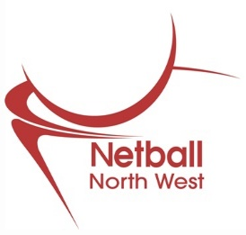
(4)

NORTH WEST NETBALL

ASSOCIATION

BOARD MEMBERS
NOMINATION FORM
FOR 2020/2021 SEASON

BOARD MEMBER POSITIONS ARE: - Vice Chair,
Coaching, Competition, Performance, Finance, Volunteer Chair

- NOMINEE
Name………………………………Position………………………
Address……………………………………………………………
…………………………………………………………………….
Tel No & Area Code:……………………………………………..
Affiliation No…………………………….Club………………….

- PROPOSER
Name………………………………………………………………
Address……………………………………………………………
…………………………………………………………………….
Tel No & Area Code:……………………………………………..
Affiliation No……………………………..Club…………………..

3 SECONDER
Name……………………………………………………………….
Address……………………………………………………………..
………………………………………………………………………
Tel No & Area Code………………………………………………..
Affiliation No ……………………………..Club…………………..

NOTE Permission must be obtained from the nominee, then return the form together with the Supporting Evidence Form to Helen Dulson, northwest@englandnetball.co.uk
Nominations must be received by the NW Regional Office no later than 5pm on Tuesday 8th September 2020.
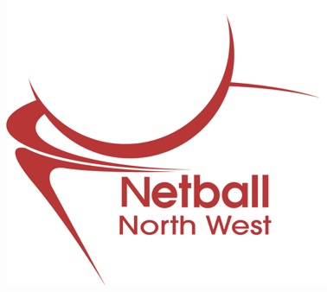
(5)

Board Nomination: Supporting Evidence Form

Please complete the following and return it with your nomination form by 5pm on Tuesday 8th September 2020.

England Netball – RMB nominations
NW Regional Office
National Cycling Centre
Stuart Street
Manchester
M11 4DQ

Or submit your application online or by email northwest@englandnetball.co.uk

PART 1: Application for the role of (please insert the position for which you are being nominated)

Part 2: Outline the reasons for applying for this position

Part 3: Detail your Experience.

Part 4: Key Skills. Tell us about the key skills and attributes that make you a suitable person for the position.

If you are interested in a role and would like a copy of the role description please email northwest@englandnetball.co.uk

Minutes from 2019 AGM

